Providing targeted clinical pharmacy services
Clinical pharmacy teams could better identify high risk and unstable patients in hospitals through the use of technology. In the context of rising demands and patient complexity it is vital that patients who will benefit most from clinical pharmacy services during the week and at weekends are clinically prioritised.
The benefit of clinical prioritisation is that it allows pharmacy services to focus on where the need is greatest and where it is likely to have the greatest impact on patient outcomes. The optimal use of electronic prescribing, in addition to other dedicated programmes - improves visibility of medication issues across the entire hospital. This gives hospitals an opportunity to systematically provide clinical pharmacy services to patients who may benefit the most.
There is emerging evidence to support this practice and better inform hospitals on how best to progress with this model.
Some hospitals around the country have progressed with providing targeted services and have found it is an enabler to providing appropriate seven day clinical pharmacy services.
We ran a focus group, inviting those hospitals to share their learning, challenges and suggestions for improvements based on their experiences. A series of design principles below were developed to support hospitals in implementation.

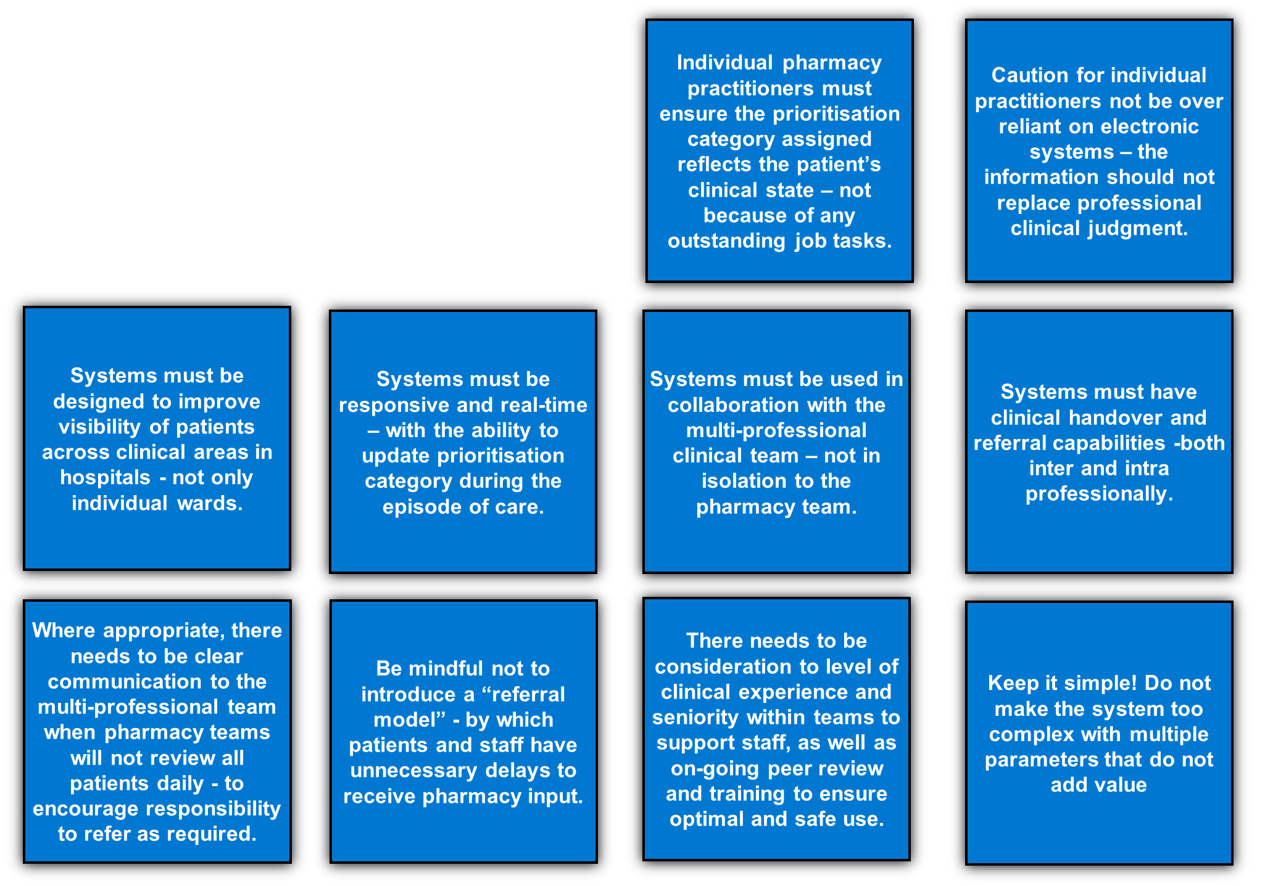
10 Design Principles for Pharmacy Clinical Triage Tools for Acute Hospitals

